Table of Contents

Discharge Program Overview Page 2
Identifying Patients to be Discharged Pages 2-3
Indicators in Patient List Activity
Expected Discharge Date

The Discharge Navigator Pages 3-8
Discharge Summary Report
Pharmacy Discharge Planning Note
Review Discharge Medications
New Prescriptions
Medication Comments
Medication Reconciliation
Pharmacy Discharge Medication History

Discharge Medication Reconciliation Pages 9-14
Discharge Medication Reconciliation Pharmacist Workflow
Physician Co-signing of Verbal Orders

Documentation Pages 14-22
Medication Reconciliation Note
Patient Education Tracking Note
Patient Education Activity
Discharge Medication Teaching Documentation
Warfarin Education Documentation
After Visit Summary

Other Tools for Discharge Medication Reconciliation Pages 23-24
Admission Reconciliation Report
Discharge to Rx History Comparison Report

Other Considerations when Performing Discharge Page 24
Medication Reconciliation

Expectations for Discharge Planning Pages 25-27
Pharmacy Discharge Planning (Sticky) Note

Discharge Program Overview

Pharmacists are responsible for discharge medication reconciliation and discharge medication teaching. During the discharge medication reconciliation process, the pharmacist has the ability to adjust discharge prescriptions using the discharge navigator based on verbal order from the physician (C-II prescription requires MD signature, requires alternative workflow). Orders adjusted by the pharmacist will be sent via in-basket to the physician for cosigning. The pharmacist will enter a discharge note to document the completion of the discharge reconciliation. They will then prepare the patient medication list and provide medication teaching. Education provided will be documented using the education activity within Epic.

IDENTIFING PATIENTS TO BE DISCHARGED

Indicators in Patient List
When the provider has released all medications in the discharge navigator a will appear in the “Discharge Med Rec Complete? [36310]” column of the patient list (you will need to add this column to your My Patient List). The “Discharge Med Rec Complete? [36309]” Yes/No column shown below is another display option of the same information.
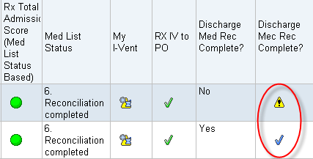

Figure 1: Columns identifying physician completion of discharge navigator.

This column will assist you in sorting your patient list but is not a perfect indicator.
As previously mentioned, all medications must be released by the provider in the navigator to flip the indicator from to .

If a new medication is entered after the indicator changes to a the indicator will change back to . If you were to rely solely on the indicators and sort your patient list by that column, you would not identify that patient as a discharge.

This indicator is helpful if you know a patient is to be discharged on a given day but their indicator shows a - it is a trigger for you to enter the navigator to see which orders have not been released.
Expected Discharge Date
Another tool that will be available to assist in identifying discharge patients is the ‘Expected Discharge Date’. The expected discharge date is available in navigators (Admission, Rounding), the Doc Flowsheet and Patient Lists. The provider is responsible for completing this field, however, physicians, pharmacists, nurses, case managers and social workers and other select individuals will also be able to add, edit, modify this field.

Figure 2: Navigator - expected discharge date

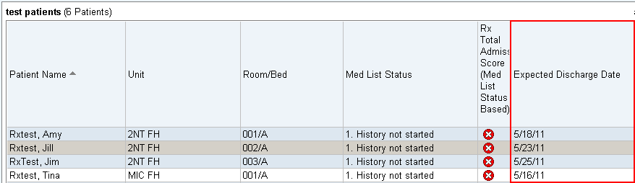

Figure 3: Patient list – expected discharge date

THE DISCHARGE NAVIGATOR

The IP Pharmacy tab opens the IP Pharmacy Navigator

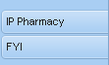

Figure 4: EPIC IP Pharmacy Navigator

The Discharge tab at the top will bring you to the Discharge Navigator

Figure 5: Discharge Documentation Tab

The tree on the left-hand side of the Discharge Navigator allows you to jump to a particular section of the navigator.

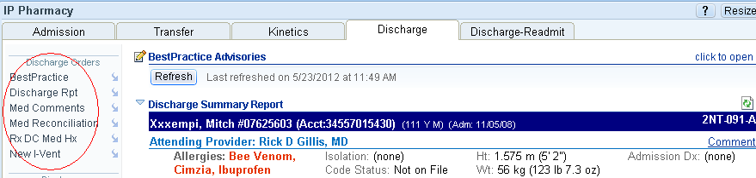

Figure 6: Discharge Navigator Tree

The Discharge Navigator contains the information and tools that will be needed to perform discharge medication reconciliation and patient education. It has several sections.

Discharge Summary Report

This section provides general information about the patient that is useful at discharge

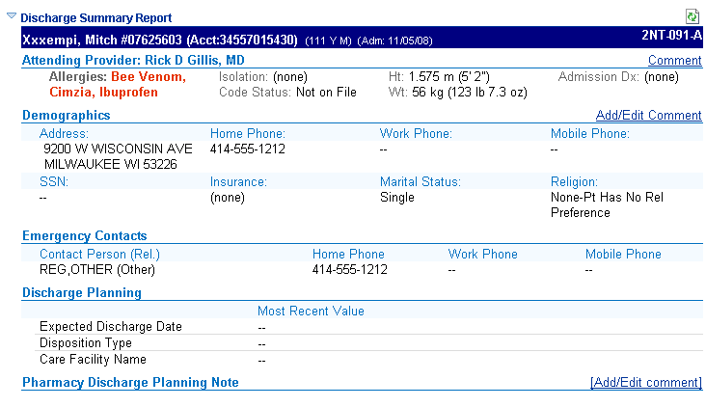Figure 7: Discharge Summary Report Section

Pharmacy Discharge Planning Note

The pharmacy discharge planning note is a tool that can be used by all disciplines to communicate information related to discharge planning. It is not a permanent part of the medical record and should not replace clinical documentation requirements. See Expectations for Discharge Planning section for more information about documentation requirements.

Figure 8: Pharmacy Discharge Planning Note

Review Discharge Medications

This section shows the current status of all PTA and inpatient medications in the discharge review process.

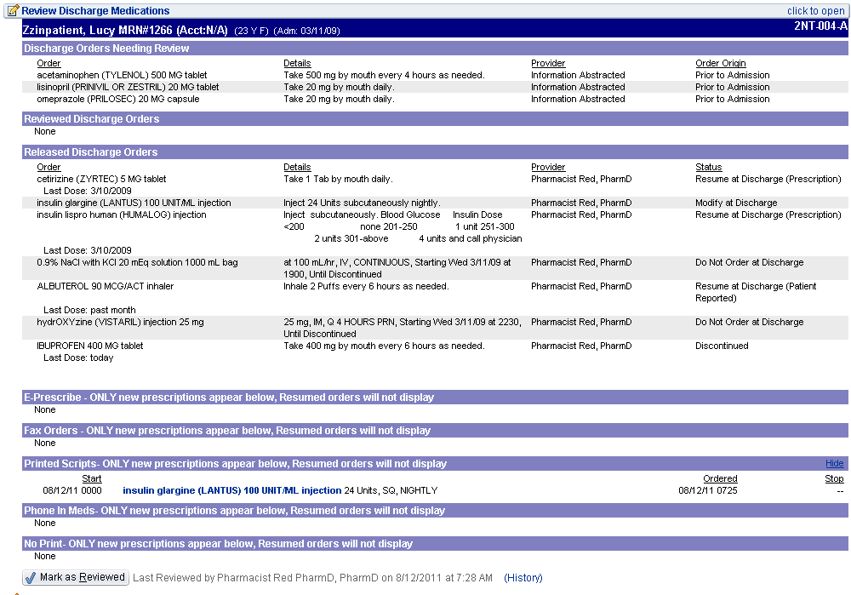
Figure 9: Review Discharge Medications Section

As previously described, if you know a patient is to be discharged and a check mark () does not appear the “Discharge Med Rec Complete?” column of the patient list, there are still medication orders that have not been released by the physician. Such orders will be seen at the top of this section under Discharge Orders Needing Review.
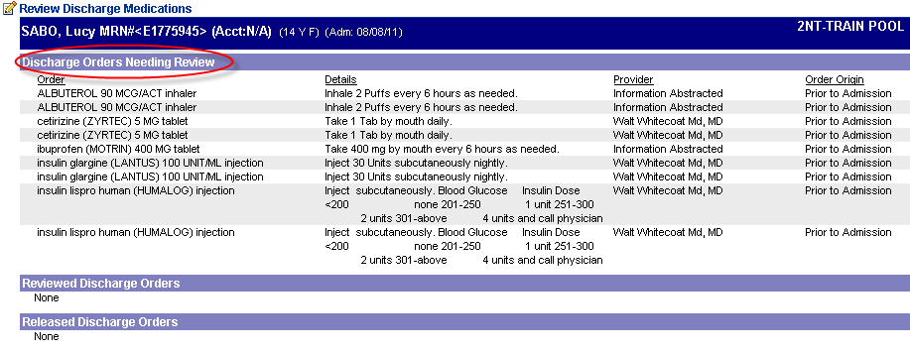
Figure 10: Discharge Orders Needing Review

Once orders have been reviewed and released by the provider, they display under Released Discharge Orders:

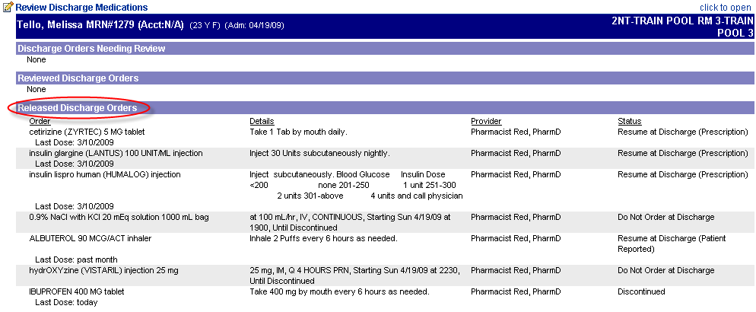

Figure 11: Released Discharge Orders

New Prescriptions

After the released discharge orders, new prescriptions will be listed by method of communication (E-prescribed, printed, faxed, ect).

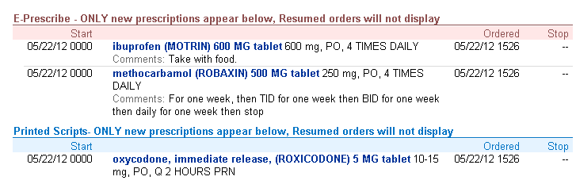
Figure 12: New Prescriptions

Medication Comments

This section includes an audit trail of all medication comments made. These comments stay with the medication list and are visible to all providers across all encounters. This section is for information that needs to remain with the patient after their discharge. This section is the same as the one seen in the Admission Navigator.

Figure 13: Medication Comments Section

Medication Reconciliation

Opening this section takes you to the Medication Reconciliation wizard. See the Discharge Medication Reconciliation Pharmacist Workflow section for more information.

Figure 14: Med Reconciliation Section (closed)

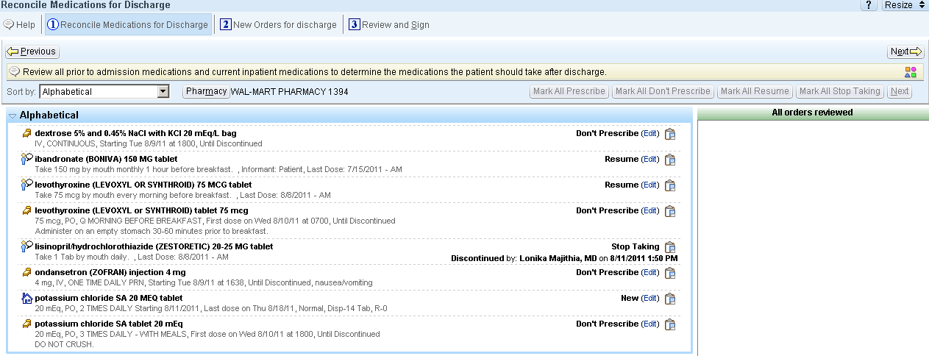

Figure 15: Med Reconciliation Section (opened)

Pharmacy Discharge Medication History

Similar to entering an Admission Medication History note, this section provides one way in which the Pharmacy Discharge Medication History note can be generated rather than searching for the note type in the Notes activity.

Figure 16: Pharmacy Discharge Medication History Section (closed)

When opened this section will default to the note that should be used to document completion of the discharge medication education. See Documentation section for more information on note types.
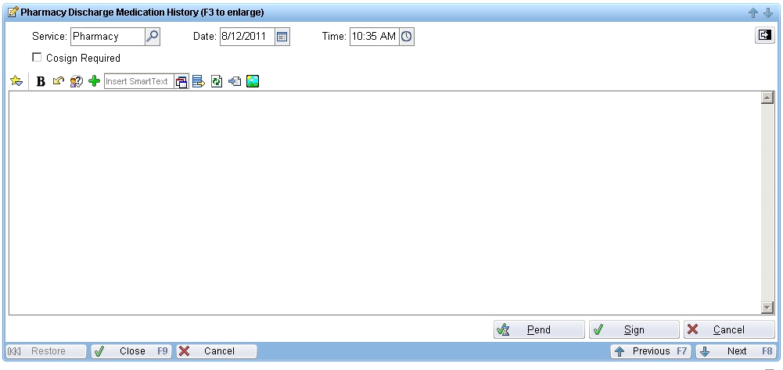

Figure 17: Pharmacy Discharge Medication History Section (opened)
DISCHARGE MEDICATION RECONCILIATION

Discharge Medication Reconciliation Pharmacist Workflow
The pharmacist accesses the medication reconciliation section of the discharge navigator from the tree on the left side of the navigator screen:

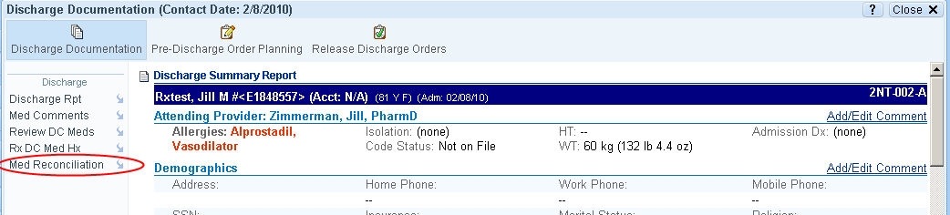

Figure 18: Navigating to Med Reconciliation

This will launch the same medication reconciliation wizard that the physicians see when processing discharge orders. The only difference is that the orders should already be reviewed by the physician at the time the pharmacist enters the wizard (reordered, discontinued, continued post discharge, etc.)

The wizard provides a comprehensive list of all PTA, inpatient, and discharge medications which can facilitate reconciliation. The list can be sorted in a number of ways including alphabetically and by therapeutic class.

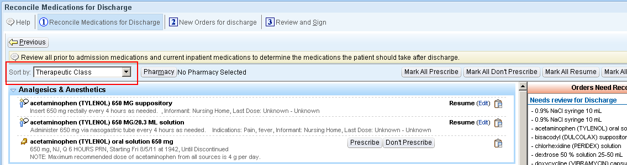

Figure 19: Medication Reconciliation Wizard

The icons to the left of the medication names indicate whether the medication was an outpatient order (), reported by the patient (), or an inpatient order (). This is a real-time tool that can be very helpful in identifying discrepancies between the lists.

The pharmacist will review the discharge medications for appropriateness and completeness. If any modifications are needed for existing prescriptions, the pharmacist will call the physician for a verbal order and then use the Edit link to adjust the prescription.

Should a new medication need to be prescribed, the pharmacist would access the 2nd tab of the wizard and input the medication using the Additional Discharge Orders field. Upon selecting the medication, the pharmacist inputs all of the necessary elements for the prescription and designates how the prescription should be processed using the appropriate order class.

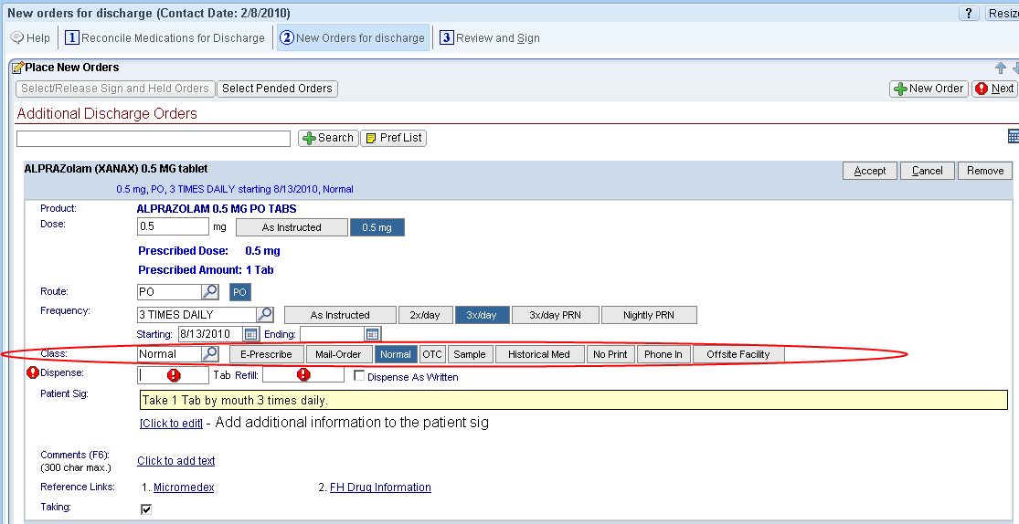

Figure 20: Selection of order class

E-Prescribe—prescription will be electronically transmitted to the patient’s pharmacy as designated on the Review and Sign page. If the pharmacy does not accept electronic prescriptions, the prescription will fax instead.
Mail-Order—used for mail order pharmacies
Normal—a prescription will print on a local printer
OTC—no prescription will print
Sample—no prescription will print
Historical Med—should only be used for recording of medications the patient has previous taken or that is prescribed by an outside provider. No prescription will print.
No Print—No prescription will print
Phone In—No prescription will print
Offsite Facility—No prescription will print

NOTE: C2 prescriptions should only be printed as they require a manual signature by the physician. When talking to a physician about changing or initiating a C2 prescription, the best course of action is to have the physician adjust the medication within Epic, regenerate a new prescription, sign it and send it home with the patient.
When all modifications and additions have been completed, the pharmacist should move to the review and sign tab. The main panel of this portion of the wizard will include the final discharge orders for the patient. The right panel will provide the action taken on all of the medications on the patient’s prior to admission and inpatient medication lists.

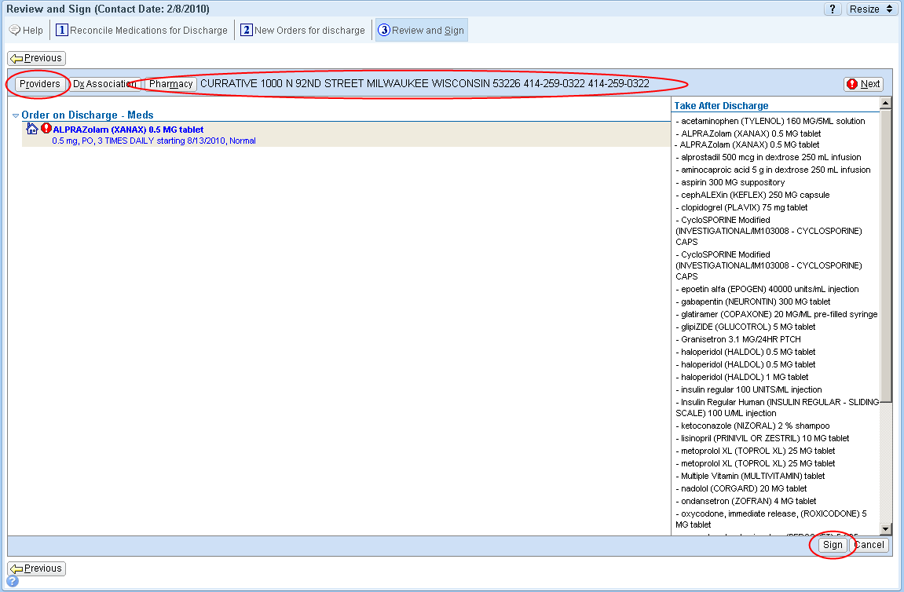

Figure 21: Selection of provider and pharmacy

Before signing any prescription changes or additions, the pharmacist must specify the provider and pharmacy using the respective buttons.

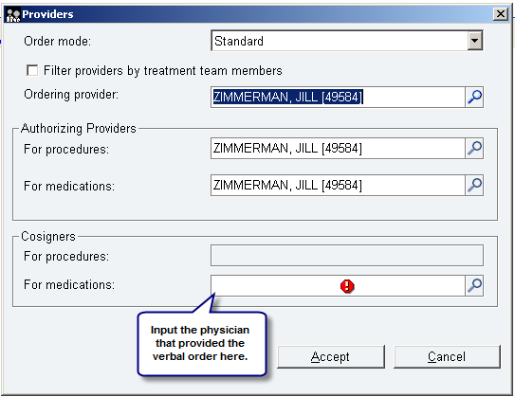

Figure 22: Routing for provider co-signature

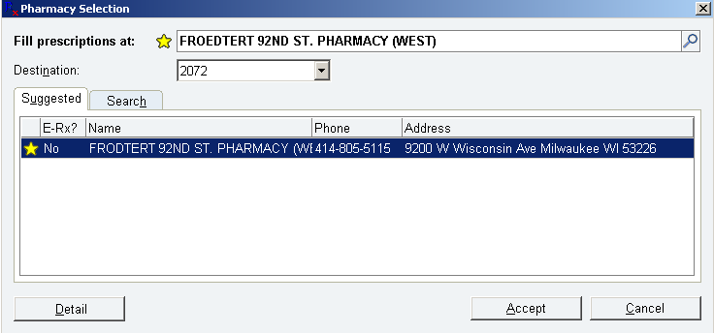

Figure 23: Selection of pharmacy

Once the provider and pharmacy have been specified, you can sign the order. At the time of signing, the prescription is routed to the pharmacy (or printer depending on the order class selected) and the co-signature is sent by in-basket message to the provider for signing.

The next time the provider logs into Epic, they will see that they have medications waiting for co-signature.

Physician Co-signing of Verbal Orders
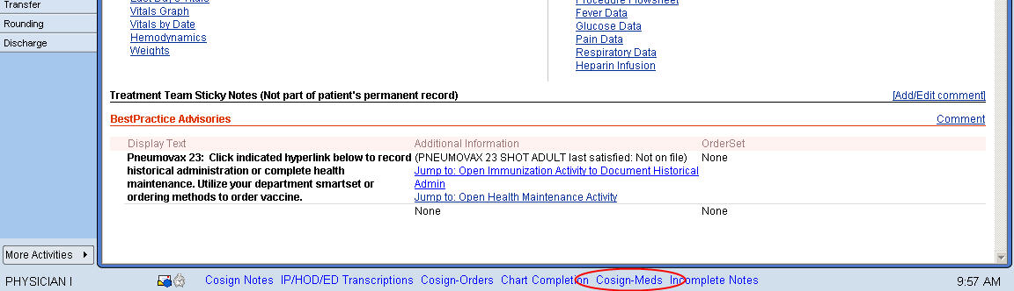

Figure 24: Provider co-signature of medication orders

When they access their inbasket, they will see all of the medications that were adjusted via verbal order to the pharmacist.

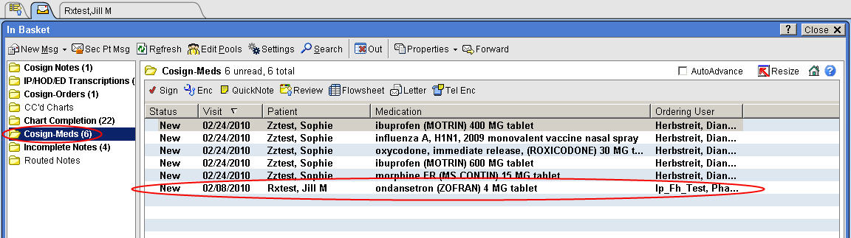

Figure 25: Selection of medication order of co-signature

The physician signs the order using the sign button and the order then moves to a Done status.

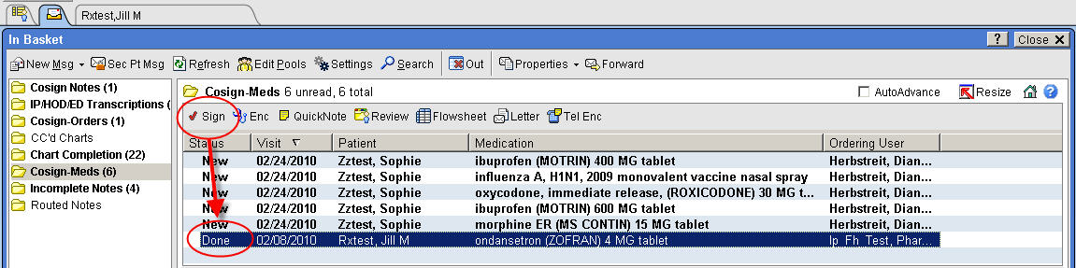

Figure 26: Completion of co-signature

DOCUMENTATION

Pharmacists will be entering two notes during the discharge process. One note will be entered upon completion of the discharge medication reconciliation and another after completion of patient education. The note type for both notes will be Pharmacy Discharge Medication History. This note type can be found by searching in the “Type” field.

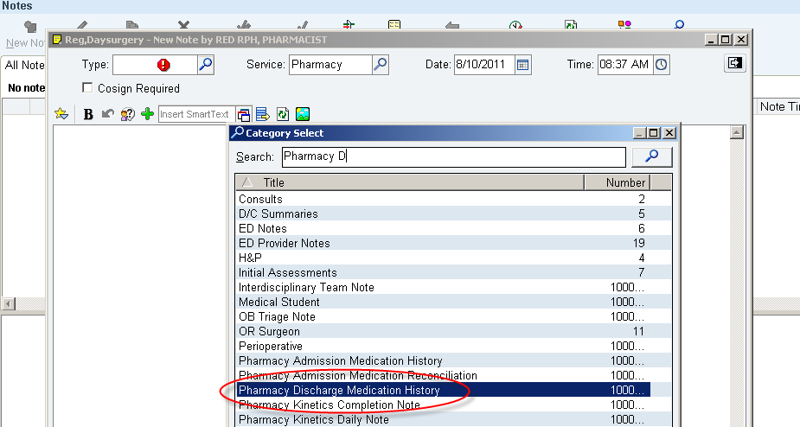

Figure 27: Pharmacy Discharge Medication History Note Type

Medication Reconciliation Note

To complete the medication reconciliation note, select Pharmacy Discharge Medication History as the note type. Then select “RX MEDICATION DISCHARGE RECONCILIATION” from SmartText. This note includes the patients discharge medication list and pharmacist’s signature.

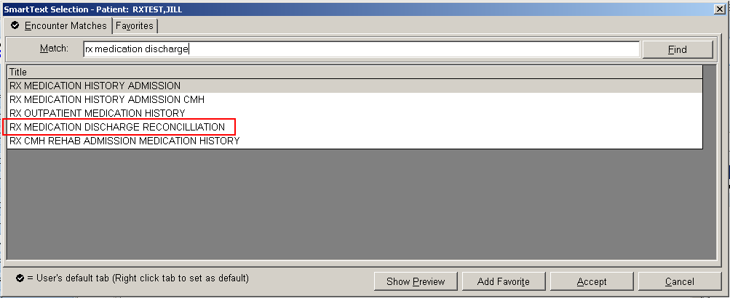

Figure 28: Smart Text Selection

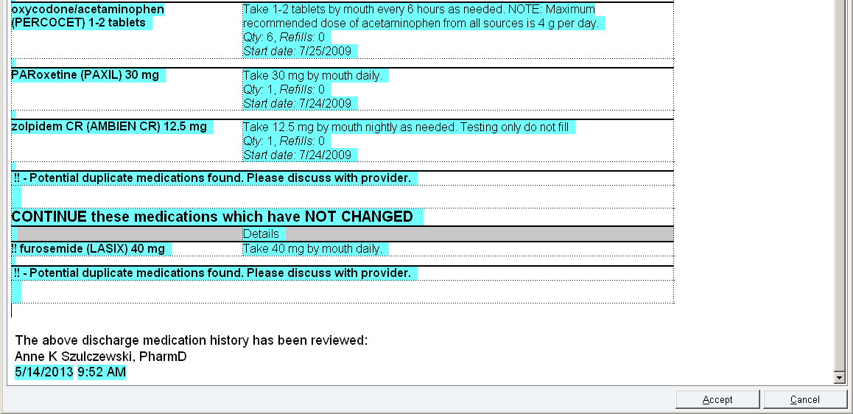

Figure 29: RX Medication History Discharge Note Example (Reconciliation Note)

Patient Education Tracking Note

A second note will be documented if patient education is completed. The purpose of this note is to track the percentage of discharge education being completed by pharmacists. The content of the education provided should be documented using the education activity (see next page). To complete the medication discharge counseling note, select Pharmacy Discharge Medication History as the note type. Then enter dotphrase .rxmeded. If the discharge medication education is not be provided by the pharmacist (if the nurse is completing teaching), this note should not be completed.
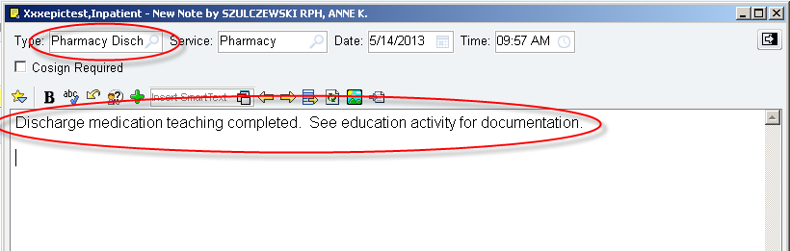

Figure 30: Patient Education Tracking Note

If both the reconciliation and education are completed by the pharmacists there should be two notes in the system. As both notes are the same note type, they will look the same when filed in the Notes tab.

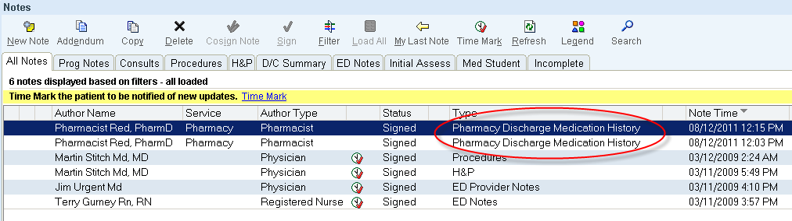
Figure 31: Reconciliation and Education Tracking Note

Completion of discharge medication reconciliation and patient education will be tracked based on the number of notes entered. If only one of this note type has been filed, it will be assumed that only the medication reconciliation has been completed. Subsequent notes will be assumed to indicate completion of patient education.

If medication education is provided to patients during their inpatient stay (e.g. solid organ transplant, BMT), the ‘Progress Note’ note type should be used when filing an education note for that activity. Discharge medication reconciliation and education will then be documented as outlined above using the Pharmacy Discharge Medication History note type.

Patient Education Activity

The content of education provided to the patient at the time of discharge should be documented using the Patient Education Activity within Epic.



Figure 32: Patient Education Activity

Discharge Medication Teaching Documentation

Education topics are generated based on the care plans that are entered by nursing staff. For the purposes of discharge medication teaching documentation, use the “Medications” point under the “Generic Teaching Goals/Outcomes.” Document the learner, readiness, method of education and response to education. In the comments field type “Discharge Education.” Click on “File” once complete.

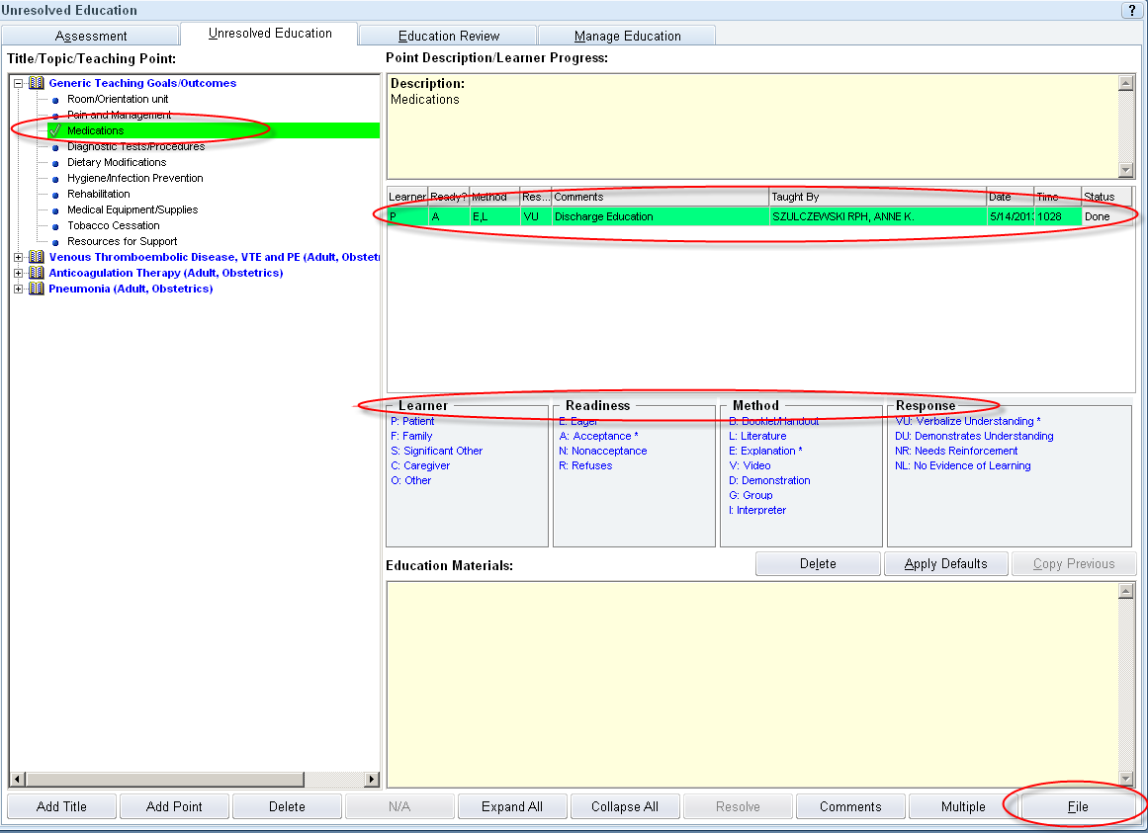

Figure 33: Documenting Discharge Education

Warfarin Education Documentation

There are very specific education documentation requirements for patients that are required by CMS. If the patient who is being educated is new to warfarin due to VTE OR was previously on warfarin but had a new VTE event, it is required that written education materials that address specific teaching points. Provision of these materials must be documented in the patient’s chart. Screenshots below show how to add anticoagulation and VTE title/topics, however, the nurse may have already added this as part of the VTE care plan.
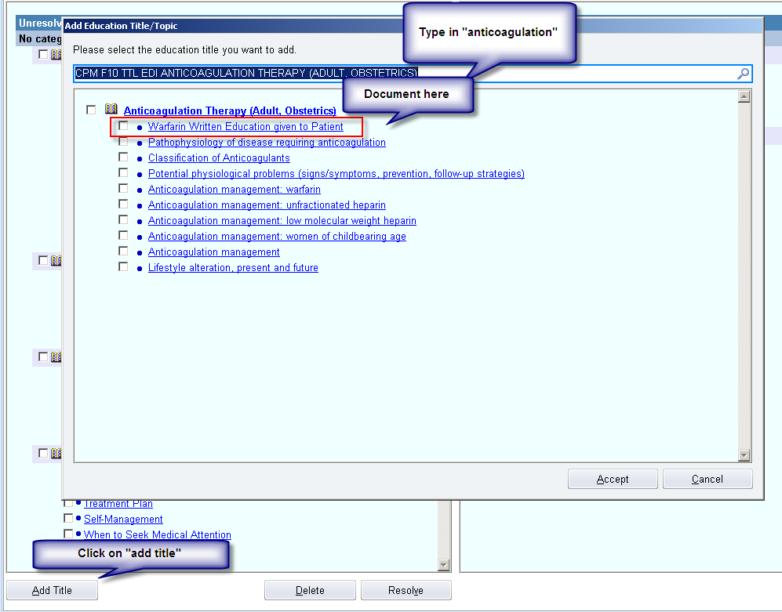

Figure 34: Addition of Anticoagulation Topic
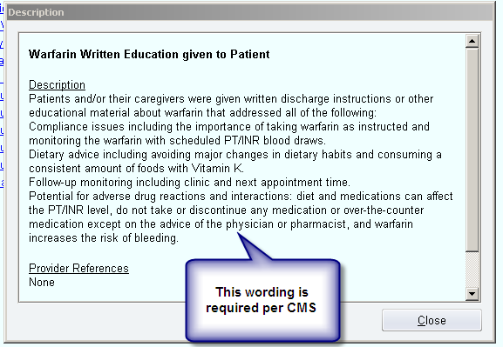

Figure 35: Warfarin Education Documentation

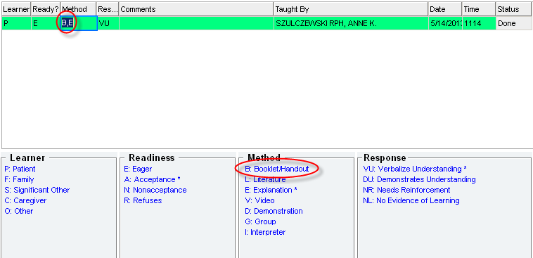
Make sure to document that a booklet/handout was provided to the patient in addition to a verbal explanation.

Figure 36: Documentation of Warfarin Handout Provided to Patient
After Visit Summary (AVS)

This is the written report that is sent home with the patient. It contains the medication list as well as their discharge instructions. Prior to printing the AVS, it is important to check with the nurse or flow coordinator to make sure the discharge instructions have been completed. You may add additional comments to the discharge instructions if needed. Remember to use “patient friendly” language. The discharge instructions box can be found in the discharge navigator.
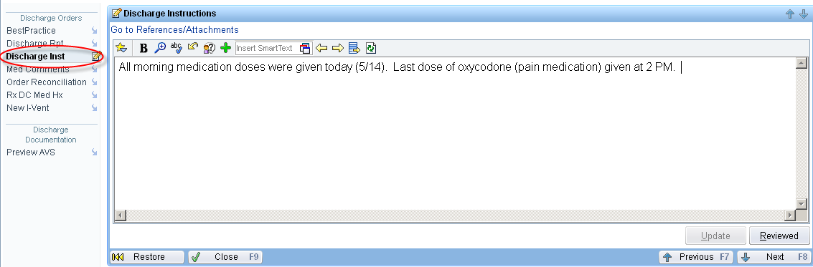

Figure 37: Discharge Instructions

To print or view the AVS, access the More Activities menu on the lower right corner of the patient chart, select Print AVS or Preview AVS. If printing, you must then select the appropriate printer.
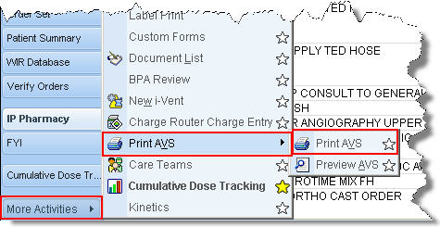

Figure 38: Printing or Previewing the After Visit Summary

The medication list within the AVS will print in a Start/Continue/Stop format. Additional comments such as the medication indication, next date due, last dose given may be hand-written on this document to increase patient understanding. If any significant change to any of the medication orders (dose, route, frequency, duration, etc) is required, the medication list within Epic should be updated and a new AVS printed.
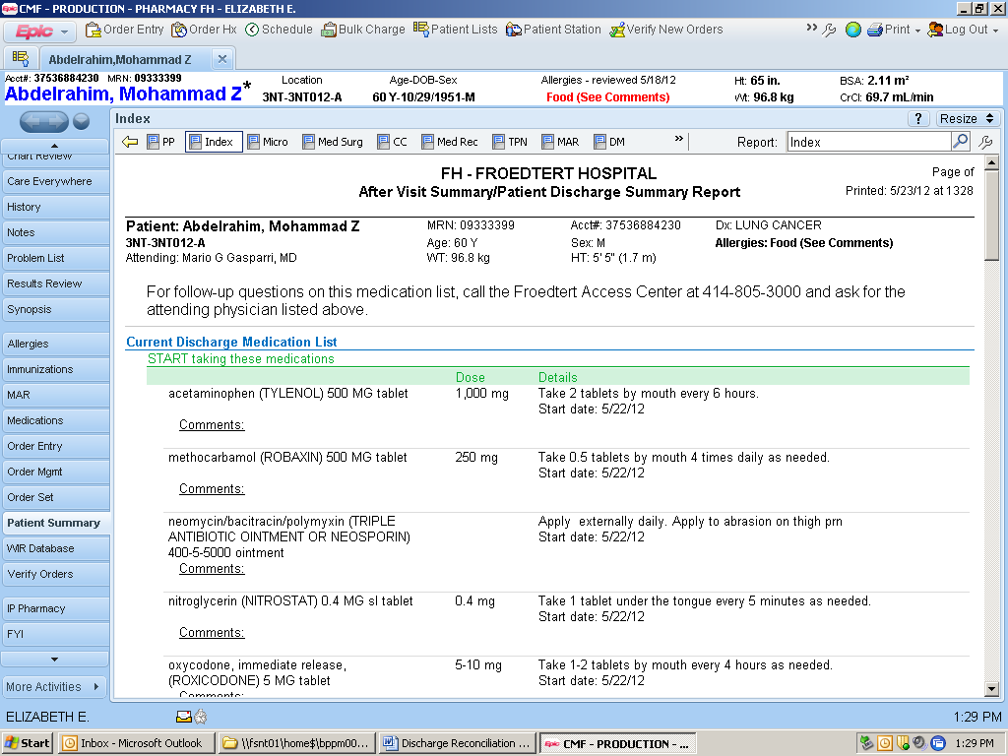
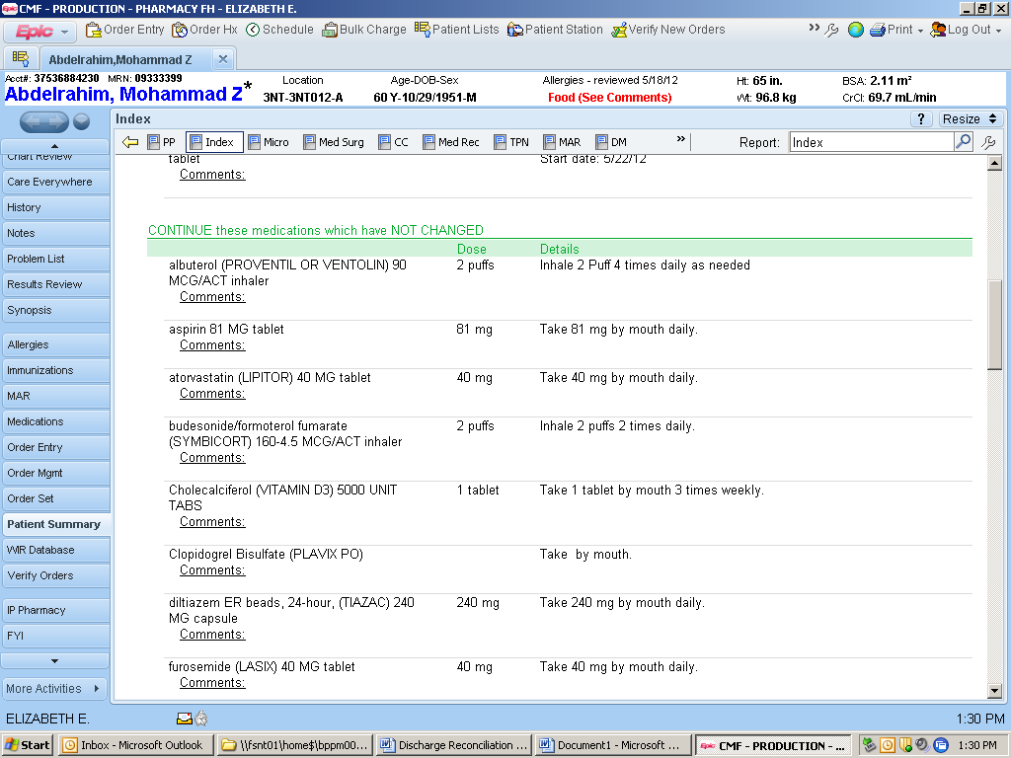
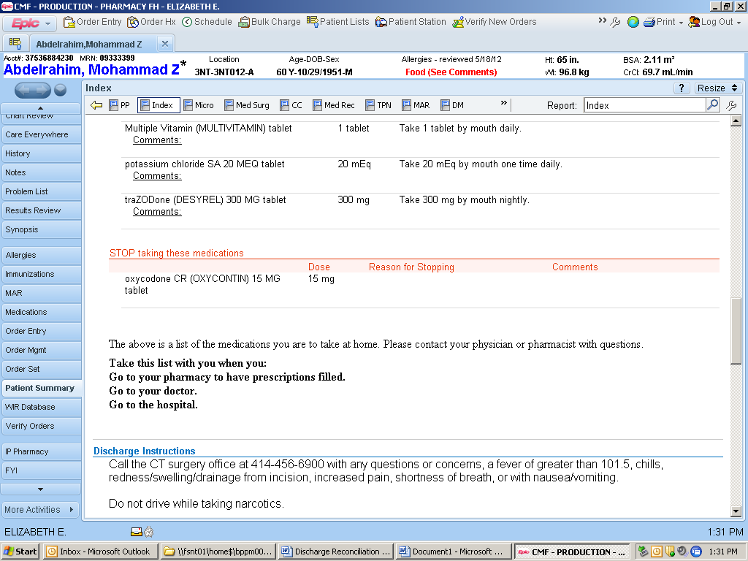

Figure 39: Medication List within the AVS

Other Tools for Performing Medication Reconciliation

The Admission Reconciliation Report and the Discharge to Rx History Comparison Report found in the Pharmacy Index report may also be used to compare PTA, Inpatient, and Discharge Medications lists when performing discharge reconciliation.

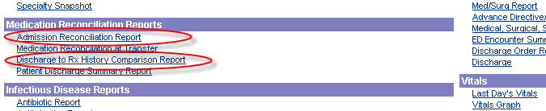

Figure 40: Medication Reconciliation Reports available in Index

Admission Reconciliation Report

This link takes you to the same report used to perform admission medication histories, providing a view of the PTA medication list.

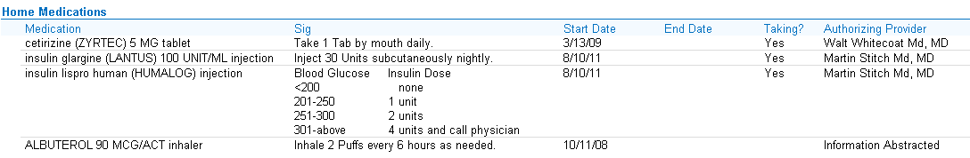

Figure 41: Admission Reconciliation Report Home Medications list

Discharge to Rx History Comparison Report
This report provides a side-by-side comparison of the released discharge medications and the Admission History note as well as the Med Comments and the notes from the pharmacist add/edit/comments fields of the patient profile. This report is helpful when discharging patients from the inpatient rehabilitation unit (5NE).
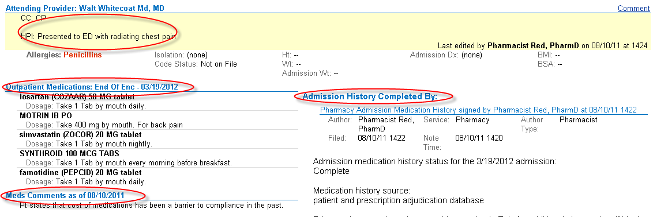

Figure 42: Discharge to Rx History Comparison Report

Other Considerations when performing Discharge Medication Reconciliation:

- Review medication administration records to assess when next doses are due and if PRN medications are necessary for discharge (MAR, Med/Surg report).

- No one report provides a good overview of therapy changes throughout admission; use the pharmacist add/edit/comments fields of the patient profile or the sticky notes to communicate changes throughout the admission to aid in discharge medication reconciliation.

- Review notes to ensure that recommendations from consult services were considered / implemented.

- Assess appropriateness of discharge medications by reviewing monitoring parameters relevant to each medication.

- High priority/alert medications:
    - Abx→ appropriateness of agent and duration/quantity based on cultures
    - Anti-coagulation→ dose, duration/quantity, access, teaching, f/u with an anticoagulation clinic
    - Insulin→ restart of home oral anti-diabetics or appropriate dosing of insulin for outpatient care
    - Anti-arrhythmics→ drug interactions, QTc
    - Opioids → doses, prn use, review for inappropriate duplicate therapy
Expectations for Discharge Planning

Pharmacy Discharge Planning (Sticky) Note

The Pharmacy Discharge Planning Note is used to communicate discharge information between pharmacists, flow coordinators, nurses, case managers and discharge technicians. Prescription insurance information, progress on prescription prior authorization and other information needed for discharge planning should be communicated here. The smart text “RX/RN/CSM IP DISCHARGE PLANNING STICKY NOTE” should be populated for each patient on admission to standardized communication.

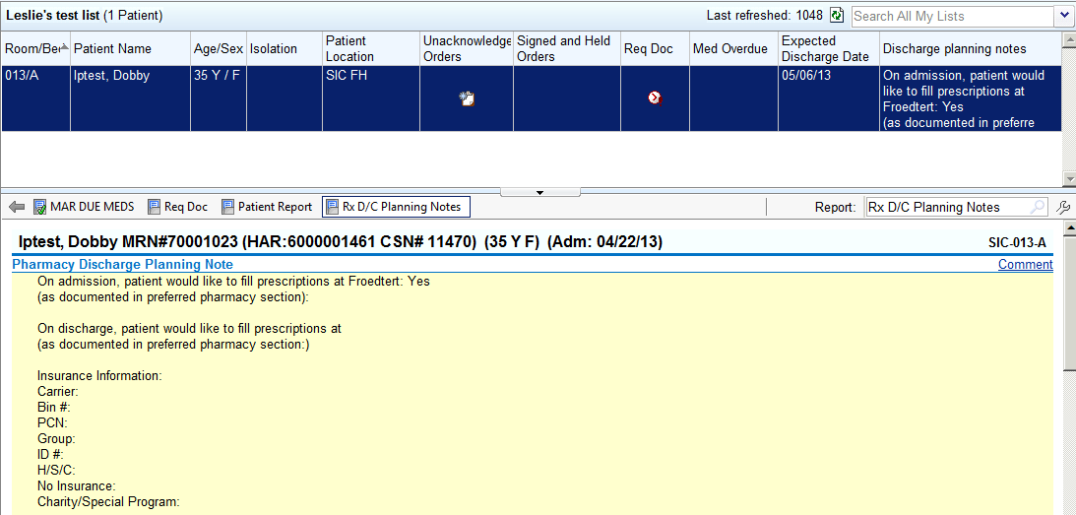

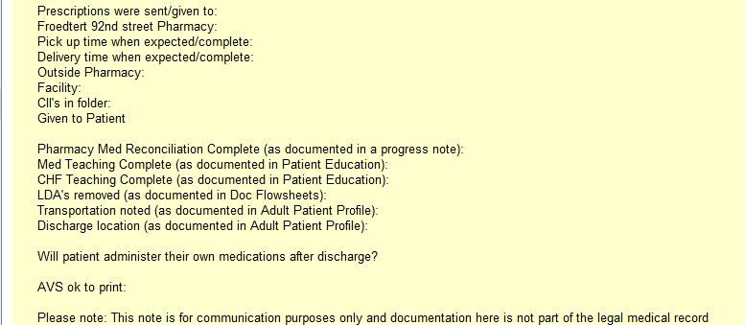

Figure 43: Pharmacy Discharge Planning Note
An additional dot phrase (.rxtestclaim) can be used to document information on the progress of prior authorizations.
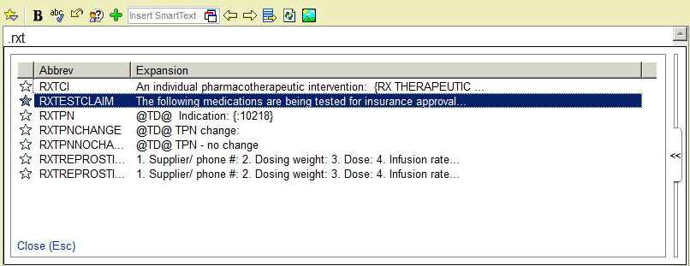

Figure 44: Prior Authorization Documentation

Additional text below will populate into the discharge planning note:

The following medications are being tested for insurance approval/cost:

Approved
Copay:
Denied
Reason for denial:
Cash price:
MD notified?
Require further communication to insurance company by MD/MD representative:
Reason for communication:
MD Notified:
Added to sticky note to MD:

Upon admission, it is expected that all patients are asked by the pharmacist/intern whether they would like to have their prescriptions filled at Froedtert when they are discharged. Admissions will scan the patient’s insurance card in the Media tab within Epic. If this information is not present or does not contain the patient’s prescription insurance information, ask the patient for it.

Patient response/insurance information should be documented in the discharge planning note. For patients with “yes” responses, the discharge technicians will review insurance information and enter the patient into the outpatient computer system in order to expedite prescription filling at discharge. On the day of discharge, it is expected that the patient also be asked where they want to fill their prescriptions (to confirm with patients who initially responded “yes” and to capture patients who may have changed their minds).
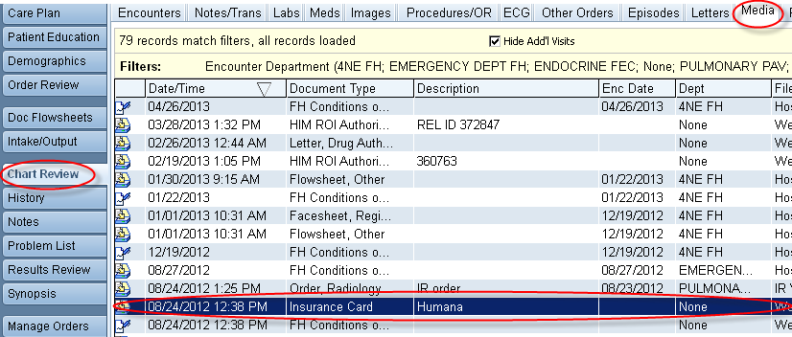

Figure 45: Media Tab – Insurance Information

